March 18, 2020
Mr. Bob Kolasky
CISA Assistant Director
National Risk Management Center

Dear Mr. Kolasky,
This letter responds to your March 17, 2020 Memo on Identification of Essential Critical Infrastructure Workers During Covid-19 for the Coronavirus Guidance for America.
As you know, the Department of Homeland Security (DHS) Cybersecurity and Infrastructure Agency (CISA) designated the PVC workforce as Tier 1 Essential workers in the agency’s 2007 analysis. The chemical industry is essential to the safety of the United States, and chemical products play a vital role in “every part of modern society in a positive way.” CISA specifically discussed the role of Polyvinyl Chloride (PVC) and its key building block, chlorine.
Chlorine serves as a disinfectant. According to the World Health Organization, chlorine’s use in water treatment represents one of the most significant advances in public health protection. Chlorine plays a key role in controlling bacteria and viruses in water that can cause human illness. (p.57)
The medical field benefited greatly from chemistry and modern health services depend upon these products. Polymer chemistry can be found in catheters, stethoscope diaphragms, and oxygen tents. PVC resins exist for tubing for IVs and blood transfusions and provide for the safe coatings around wires and cables. (ibid)
Chlorine and its co-product alkali also are essential ingredients in caustic soda, used to produce soaps and detergents, as well as pharmaceuticals and other medical analgesics. PVC is widely used as an effective product in preserving food with wraps, can and lid liners. In addition to blood bags and IVs, PVC is widely used for pharmaceutical packaging, as well as medical and food preparation gloves. PVC has been specified by the World Health Organization for use in personal protective equipment to be used by health care workers, including oxygen and endotracheal tubes, aprons, goggles, and others.
The people who operate the chemical facilities are also essential. These include: plant managers who monitor the entire production process; industrial machinery mechanics who maintain and repair the equipment; testers who ensure the facility is run efficiently and meets all standards; and transportation and material moving workers who deliver the materials. Again, the 2007 analysis noted, “For these jobs, the sector requires experienced workers with knowledge of chemical hazards, safety procedures, and regulations governing the transport of hazardous chemicals.”
Inasmuch as CISA has consistently recognized the PVC industry and its workforce as essential, the Vinyl Institute asks for continued inclusion as Tier 1 Essential in the Coronavirus Guidance for America.
Thank you.

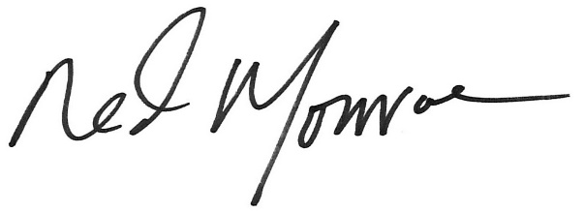

Ned Monroe
President and CEO

The Vinyl Institute, founded in 1982, is a U.S. trade organization representing the leading manufacturers of vinyl, vinyl chloride monomer, and vinyl additives and modifiers. The Vinyl Institute serves as the voice for the vinyl industry, engaging industry stakeholders in shaping the future of the vinyl industry. The U.S. vinyl industry encompasses nearly 3,000 vinyl manufacturing facilities, more than 350,000 employees and an overall economic value of $54B.

